**Linear Algebra that every Machine Learning Engineer should know👨🏻‍💻👨🏻‍🎓!!**

[[Dhilip Maharish](https://medium.com/@dhilip_maharish?source=post_page-----eb585e0ef18d--------------------------------)](https://medium.com/@dhilip_maharish?source=post_page-----eb585e0ef18d--------------------------------)

[[AI Mind](https://pub.aimind.so/?source=post_page-----eb585e0ef18d--------------------------------)](https://pub.aimind.so/?source=post_page-----eb585e0ef18d--------------------------------)

[Dhilip Maharish](https://medium.com/@dhilip_maharish?source=post_page-----eb585e0ef18d--------------------------------)

·

[Follow](https://medium.com/m/signin?actionUrl=https%3A%2F%2Fmedium.com%2F_%2Fsubscribe%2Fuser%2F9c6dfb453a3&operation=register&redirect=https%3A%2F%2Fpub.aimind.so%2Flinear-algebra-that-every-data-scientist-should-know-eb585e0ef18d&user=Dhilip+Maharish&userId=9c6dfb453a3&source=post_page-9c6dfb453a3----eb585e0ef18d---------------------post_header-----------)

Published in

[AI Mind](https://pub.aimind.so/?source=post_page-----eb585e0ef18d--------------------------------)

·

10 min read

·

Sep 10

1.3K

5

**Linear algebra is the bridge between raw data and data-driven decisions.**



**Source: Pixels Images**

Inthe world of Data Science, there is concept which makes machine learning model with nice representation, optimization and manipulation of data. It acts like behind pillar of Machine Learning model.

yes, it is none other than **Linear Algebra.**The basic foundation in building and developing machine learning model in Data Science.

In this article we are going to explore how Linear Algebra contributes to Machine Learning in Data Science. They help to understand machine learning model in graphical way which we human are good in understanding through visuals geometry.

so, lets deep dive into the essential Linear algebra that makes Data Science so powerful.

First, we can get clear on this **what data science is?**

The title itself explains you, taking Data and applying **scientifical** concepts like **statistics**, **probability** and **calculus** to derive the meaningful insights out of it.

**Data Science is understanding Past information and predicting future information.**

Examples:

Data science helps us predict the future, like a weather forecast telling us if it will rain tomorrow. It is not a magic it uses number and machine learning. It’s about finding the truth in data. It helps us answer questions and solve problems.

Now we can get into **What is Linear Algebra and why we need in data science how it contributes in it?**

Linear algebra is the branch of Mathematics that deals with **vector spaces**, **matrices** and **linear** relationship with each vector. It is empowering us to solve complex problems across diverse domains, from **engineering**and **physics** to **data science** and **computer graphics**.

Now let see why it is important in Data Science,

In the context of data science, particularly in machine learning, the significance of linear algebra becomes evident when dealing with datasets that have numerous features, making visualization and manual judgment challenging. While we can easily visualize and draw lines in 2 or 3-dimensional Cartesian space, real-world datasets often involve a high-dimensional space (N-dimensions) that is impractical to visualize. This is where the power of linear algebra comes into play. It allows us to apply mathematical principles to machine learning models, enabling the creation of decision boundaries or planes in N-dimensional space for accurate data classification and analysis.

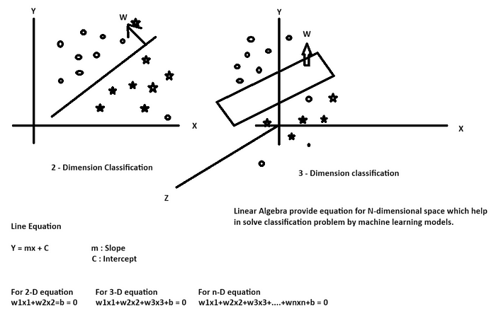

**Source: Dhilip Maharish- Author**

**Linear Algebra is the backbone of Machine Learning model algorithm in Data science.**

It contributes in the process in data science, such as

✅**Linear Algebra in** **Data Representation**

✅**Linear Algebra in** **Data Preprocessing**

✅**Linear Algebra in** **Dimensionality Reduction**

✅**Linear Algebra in Feature Engineering**

✅**Linear Algebra** **in Machine Learning Algorithm**

✅**Linear Algebra in** **Recommendation Systems**

✅**Linear Algebra in Model Interpretation**



**Source: Pixels Images**

Let discuss one by one on the above topic,

**1. Linear Algebra in Data Representation**

Data representation includes transforming data into **vectors** and **matrices**, which are structured mathematical objects that can be manipulated to perform operations like **addition**, **multiplication**, and **transformation**.

➡️**Vector**- It represent the individual **data point** from the entire data.

➡️**Matrix**- It represent with multiple**feature column** which in short form we called as**Dataset**.

➡️**Matrix Operation**- Matrix operation such as **addition**, **subtraction** and **multiplication** element-wise helps in various **transformation** and modelling technique.

➡️**Matrix Transpose**- It Creates a new matrix where rows become columns and vice versa.

➡️**Sparse Matrix**- A sparse matrix is a matrix where most of its elements are **zero**. It is used when dealing with large datasets or high-dimensional data where most values are zero, such as in text data (term-document matrices) or in certain scientific simulations.

➡️**Dense Matrix**- A dense matrix is a matrix where most of its elements are **non-zero**. It is used when you have a relatively small matrix with most entries being non-zero, or when computational efficiency is a higher priority than memory usage.

➡️**Singular Matrix**- A singular matrix is a **square matrix**(a matrix with the same number of rows and columns) that doesn’t have an inverse.

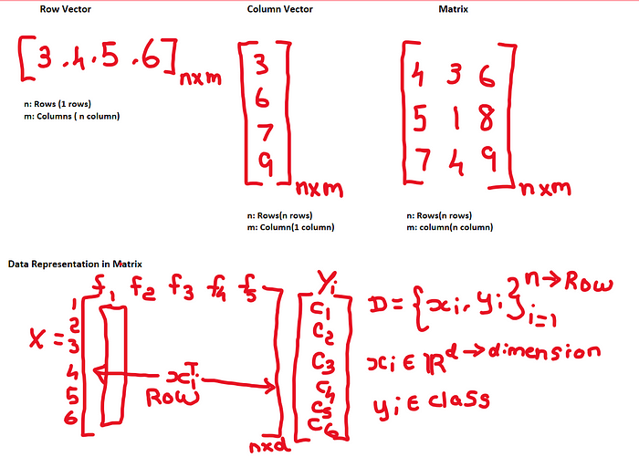

**Source: Dhilip Maharish- Author**

**2. Linear Algebra in Data Preprocessing**

Data preprocessing in the context of linear algebra involves various techniques and operations applied to **raw data** to make it suitable for **analysis**, **modeling**, or other mathematical operations using linear algebra.

➡️**Data Scaling**- It used to transform and**standardize** the numeric features of a dataset to a **common scale** and ensure that all features contribute equally to the analysis and modeling processes.

➡️**Normalization**- It scales the data to a specific range, usually between 0 and 1.

Formula: (X — X_min) / (X_max — X_min)

➡️**Standardization-** ItScales the data to have a **mean** of 0 and a **standard deviation** of 1.

Formula: (X — mean(X)) / std(X)

➡️**Robust Scaling**- It Scales data by subtracting the **median** and dividing by the **interquartile range (IQR)**.It is less sensitive to outliers compared to min-max scaling and standardization.

formula: (X — median(X)) / IQR(X)

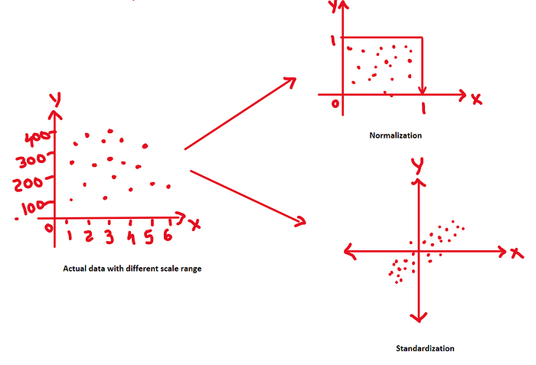

**Source: Dhilip Maharish- Author**

**3. Linear Algebra in Dimensionality Reduction**

Linear algebra plays a fundamental role in dimensional reduction techniques, which are used to reduce the **number of features** (dimensions) in a dataset while **preserving** as much **relevant information** as possible. Linear algebra techniques like **PCA** and **eigen decomposition** are commonly used in these methods.

➡️**Eigenvalue**- Eigenvalues (λ) are **scalars** associated with a **square matrix** (typically denoted as A). They represent how the matrix scales or stretches space along certain directions.

➡️**Eigenvector**- Eigenvectors (v) are **non-zero vectors** corresponding to eigenvalues (λ). When multiplied by the matrix A, eigenvectors are only scaled, with the eigenvalue being the scaling factor: A * v = λ * v.

➡️**Principal Component Analysis (PCA)**- PCA is a popular linear dimensional reduction technique that uses linear algebra to transform data into a new coordinate system.

1. It calculates the **eigenvectors** and **eigenvalues** of the **covariance matrix** of the data.
2. Linear combinations of the original features are computed using the **eigenvectors** to create new features (**principal components**).
3. These principal components are sorted by **eigenvalue magnitude**, allowing you to choose a subset to retain while discarding less informative components.

➡️**Singular Value Decomposition (SVD)**- SVD is a linear algebra technique that can be applied to the **Term Document Matrix** to perform dimensionality reduction or feature extraction.

By decomposing the TDM into three matrices (U, Σ, V^T),

where U and V are **orthogonal matrices**and Σ is a **diagonal matrix** of singular values, you can extract the most important dimensions (topics) in the data.

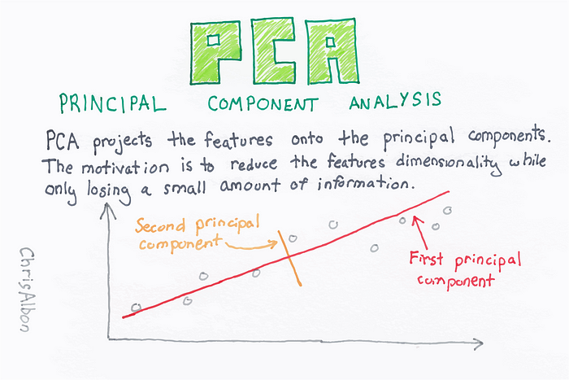

**Source: Google images**

**4. Linear Algebra in Feature engineering**

Linear algebra plays a significant role in feature engineering, which is the process of creating new features or transforming existing ones to improve the performance of machine learning models.

➡️**Feature Transformation**- Linear algebra allows you to apply various transformations to features. For example, you can take the **square root** or **logarithm of a feature** to change its **distribution** and make it more suitable for certain algorithms. Feature transformation can also help reduce **skewness** or make data more linear, which is beneficial for **linear models**.

➡️**Feature Cross-Products**- Linear algebra enables the creation of new features through **cross-products** of existing features. For example, in polynomial regression, you can include interaction terms by multiplying two or more features together.

➡️**Feature Selection**- Techniques like **forward selection** and**backward elimination** in feature selection often involve linear algebra computations. These methods aim to identify the most informative subset of features based on their impact on model performance.

➡️**Encoding Categorical Variables**- One-hot encoding and other encoding techniques for **categorical variables**involve linear algebra operations. For example, one-hot encoding creates **binary vectors** to represent categorical values as numerical features.



**Source: Pixel Images**

**5. Linear Algebra in Machine Learning Algorithm**

In Mathematics, particularly linear algebra, forms the foundation of many machine learning algorithms.

➡️**Euclidean Distance**- It is a measure of the straight-line distance between two points in Euclidean space. This concept is mostly used in **K-NN** Machine Learning algorithm.

➡️**Manhattan Distance**- It is a measure of the distance between two points in a grid-based system, such as a city grid, where you can only move horizontally or vertically (not diagonally). This concept is used in **K-NN**, **hierarchical clustering** and **density-based clustering** algorithm.

➡️​**Unit Vector**- A unit vector, also known as a **normalized vector**, is a vector with a **magnitude** (or length) of 1. It has the same direction as the original vector but has been scaled down to have a length of 1. This concept is used in **Support vector machine** algorithm.

➡️**​Distance From point to plane**- It is the shortest distance from the point to the plane, meaning it’s the distance along the perpendicular line from the point to the plane. If the result is positive, it means the point is on the same side of the plane as the normal vector and if the result is negative, it’s on the opposite side of the plane. This concept is mostly used in **Linear** and **Logistic Regression** and **Support Vector machine**algorithm.

➡️**Kernel function**- This transformation allows linear algorithms to solve nonlinear problems. It makes possible to perform complex calculations efficiently by working in the original feature space. This concept mostly used in **Support Vector Machine**.

1. **Linear Kernel**: Represents the original data without any transformation, essentially performing linear calculations.
2. **Polynomial Kernel**: Maps data into a higher-dimensional space using a polynomial function, such as *K*(*x*,*y*)=(*x*⋅*y*+*c*)*d*, where *d* is the degree of the polynomial.
3. **Radial Basis Function (RBF) Kernel**: Often used for Gaussian-like transformations, *K*(*x*,*y*)=exp(−*γ*∥*x*−*y*∥2), where *γ* is a positive constant.

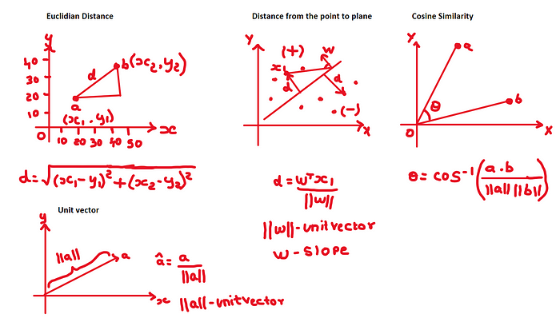

**Source: Dhilip Maharish- Author**

**6. Linear Algebra in Recommendation System**

Linear algebra plays a fundamental role in recommendation systems, which are algorithms designed to suggest items (e.g., products, movies, music, articles) to users based on their preferences and behavior.

➡️**Matrix Factorization-**Matrix factorization techniques, including **Singular Value Decomposition** (SVD), Non-Negative Matrix Factorization (NMF), and matrix factorization with gradient descent, are extensively used in recommendation systems. These techniques decompose the **user-item interaction matrix** into lower-dimensional matrices representing latent factors for users and items.

➡️**User-Item Interaction Matrix**- In recommendation systems, **user behavior** and preferences are often represented in a **user-item interaction matrix**. This matrix has users as rows, items as columns, and the entries represent user interactions with items (e.g., ratings, purchase history, clicks). Linear algebra operations, such as matrix multiplication, are used to analyze and process this interaction matrix.

➡️**Content-Based Filtering**- Content-based recommendation systems use linear algebra to represent **items** and **user** profiles as **feature vectors**. Linear algebra operations like vector dot products and similarity calculations help find items that match a user’s profile based on feature vectors.

➡️**Collaborative Filtering-**Collaborative filtering methods, like **User-Based** and **Item-Based** Collaborative Filtering, leverage linear algebra to compute similarities between users or items. This method helps **identify users**or **items**that are similar to each other and recommend items based on the preferences of **similar users**.

➡️**Cosine Similarity**- It is the measure of **cosine of the angle** between two **vectors**, providing a measure of their similarity regardless of their magnitude.



**Source: Pixel Images**

**7. Linear Algebra in Model Interpretation**

Model interpretation using linear algebra involves a detailed analysis of a machine learning model’s coefficients, relationships between variables, and the impact of individual features on model predictions.

➡️**Coefficient Interpretation**- In linear regression, the model can be represented as follows:

*y*^​=*β*0​+*β*1​*x*1​+*β*2​*x*2​+…+*βp*​*xp*

Where:

* *y*^​ is the predicted target variable.
* *β*0​ is the intercept or bias term.
* *β*1​,*β*2​,…,*βp*​ are the coefficients for the predictor variables *x*1​,*x*2​,…,*xp*​.​

These coefficients represent the change in the predicted target variable for a one-unit change in the corresponding predictor variable while holding all other predictors constant.

➡️**Orthogonalization**- Linear algebra allows you to orthogonalize predictor variables, making them **uncorrelated**. This simplifies interpretation because you can analyze the impact of each **feature independently**.

➡️**Residual Analysis**- Linear algebra helps calculate**residuals**, which are the differences between **actual**and **predicted**values. Residual plots can be used to assess the model’s fit and detect patterns or non-linearity.

➡️**Feature Importance**- To understand which features are important, you can examine the **magnitudes of the coefficients**. Larger absolute values indicate stronger influences on the target variable.



**Source: Pixel Images**

**Conclusion:**

In conclusion, linear algebra is the foundational mathematical framework which is core principles of data science. From**data manipulation** and **transformation** to machine learning **model interpretation**, linear algebra is an indispensable tool that every data scientist should know. By understanding the key concepts, such as **matrices**, **vectors**, **eigenvalues**, and **eigenvectors**, data scientists can efficiently **process**, **analyze**, and **extract insights** from complex datasets.

If you like the above article kindly provide claps and

Follow me in medium: [Dhilip Maharish — Medium](https://medium.com/@dhilip_maharish)

Follow me in Linkedin: [Dhilip Maharish | LinkedIn](https://www.linkedin.com/in/dhilip-kumar-ds/)

**A Message from AI Mind**



Thanks for being a part of our community! Before you go:

* 👏 Clap for the story and follow the author 👉
* 📰 View more content in the [AI Mind Publication](https://pub.aimind.so/)
* 🧠 Improve your [AI prompts effortlessly and FREE](https://www.aimind.so/prompt-generator?utm_source=pub&utm_medium=message)
* **🧰 Discover**[**Intuitive AI Tools**](https://www.aimind.so/?utm_source=pub&utm_medium=message)